**Project VPN**

**Objective: To set up a VPN server and connect a computer to it as a client.**

Made a new droplet and picked San Francisco as the place.

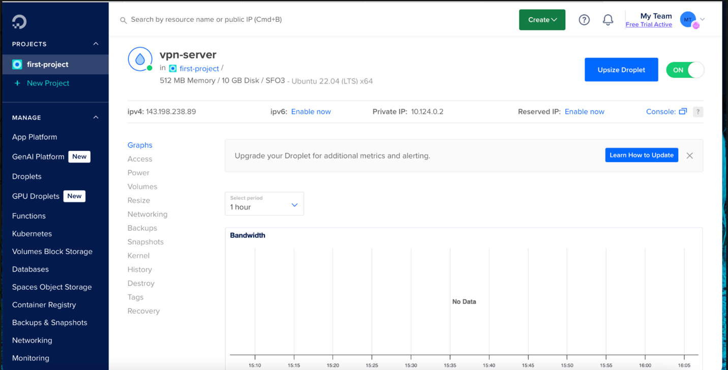

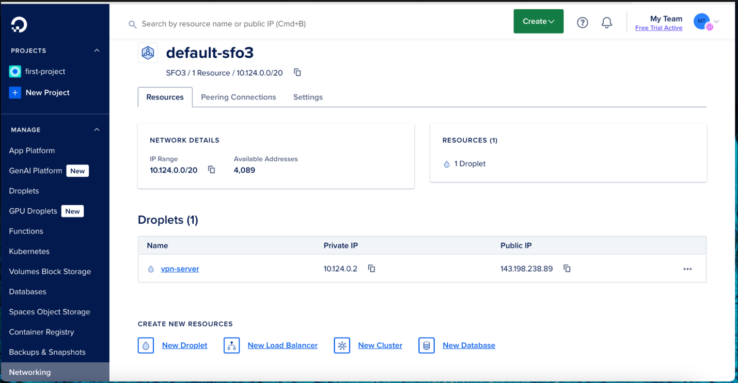

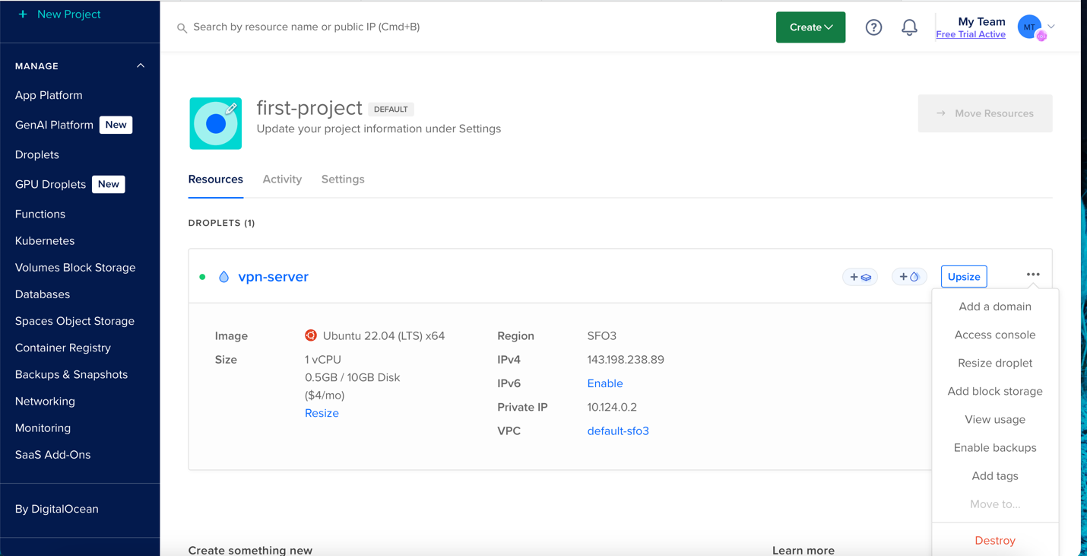

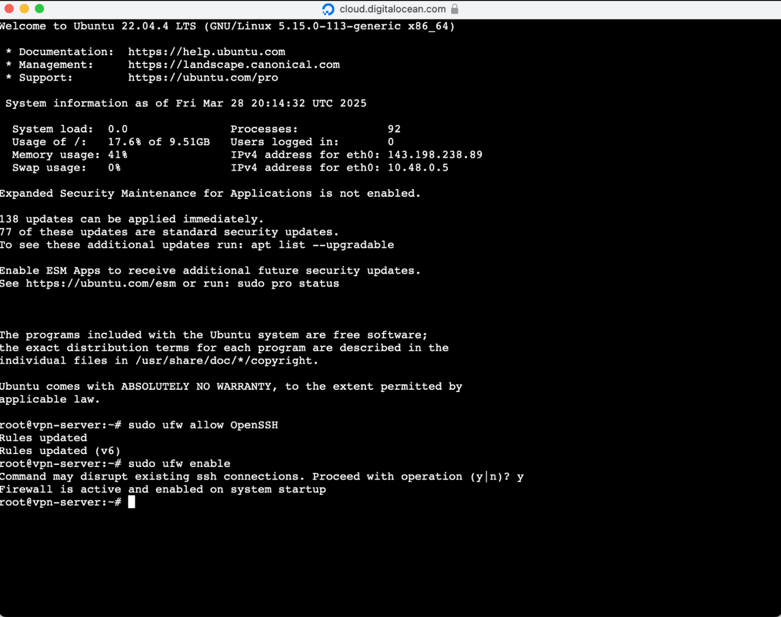

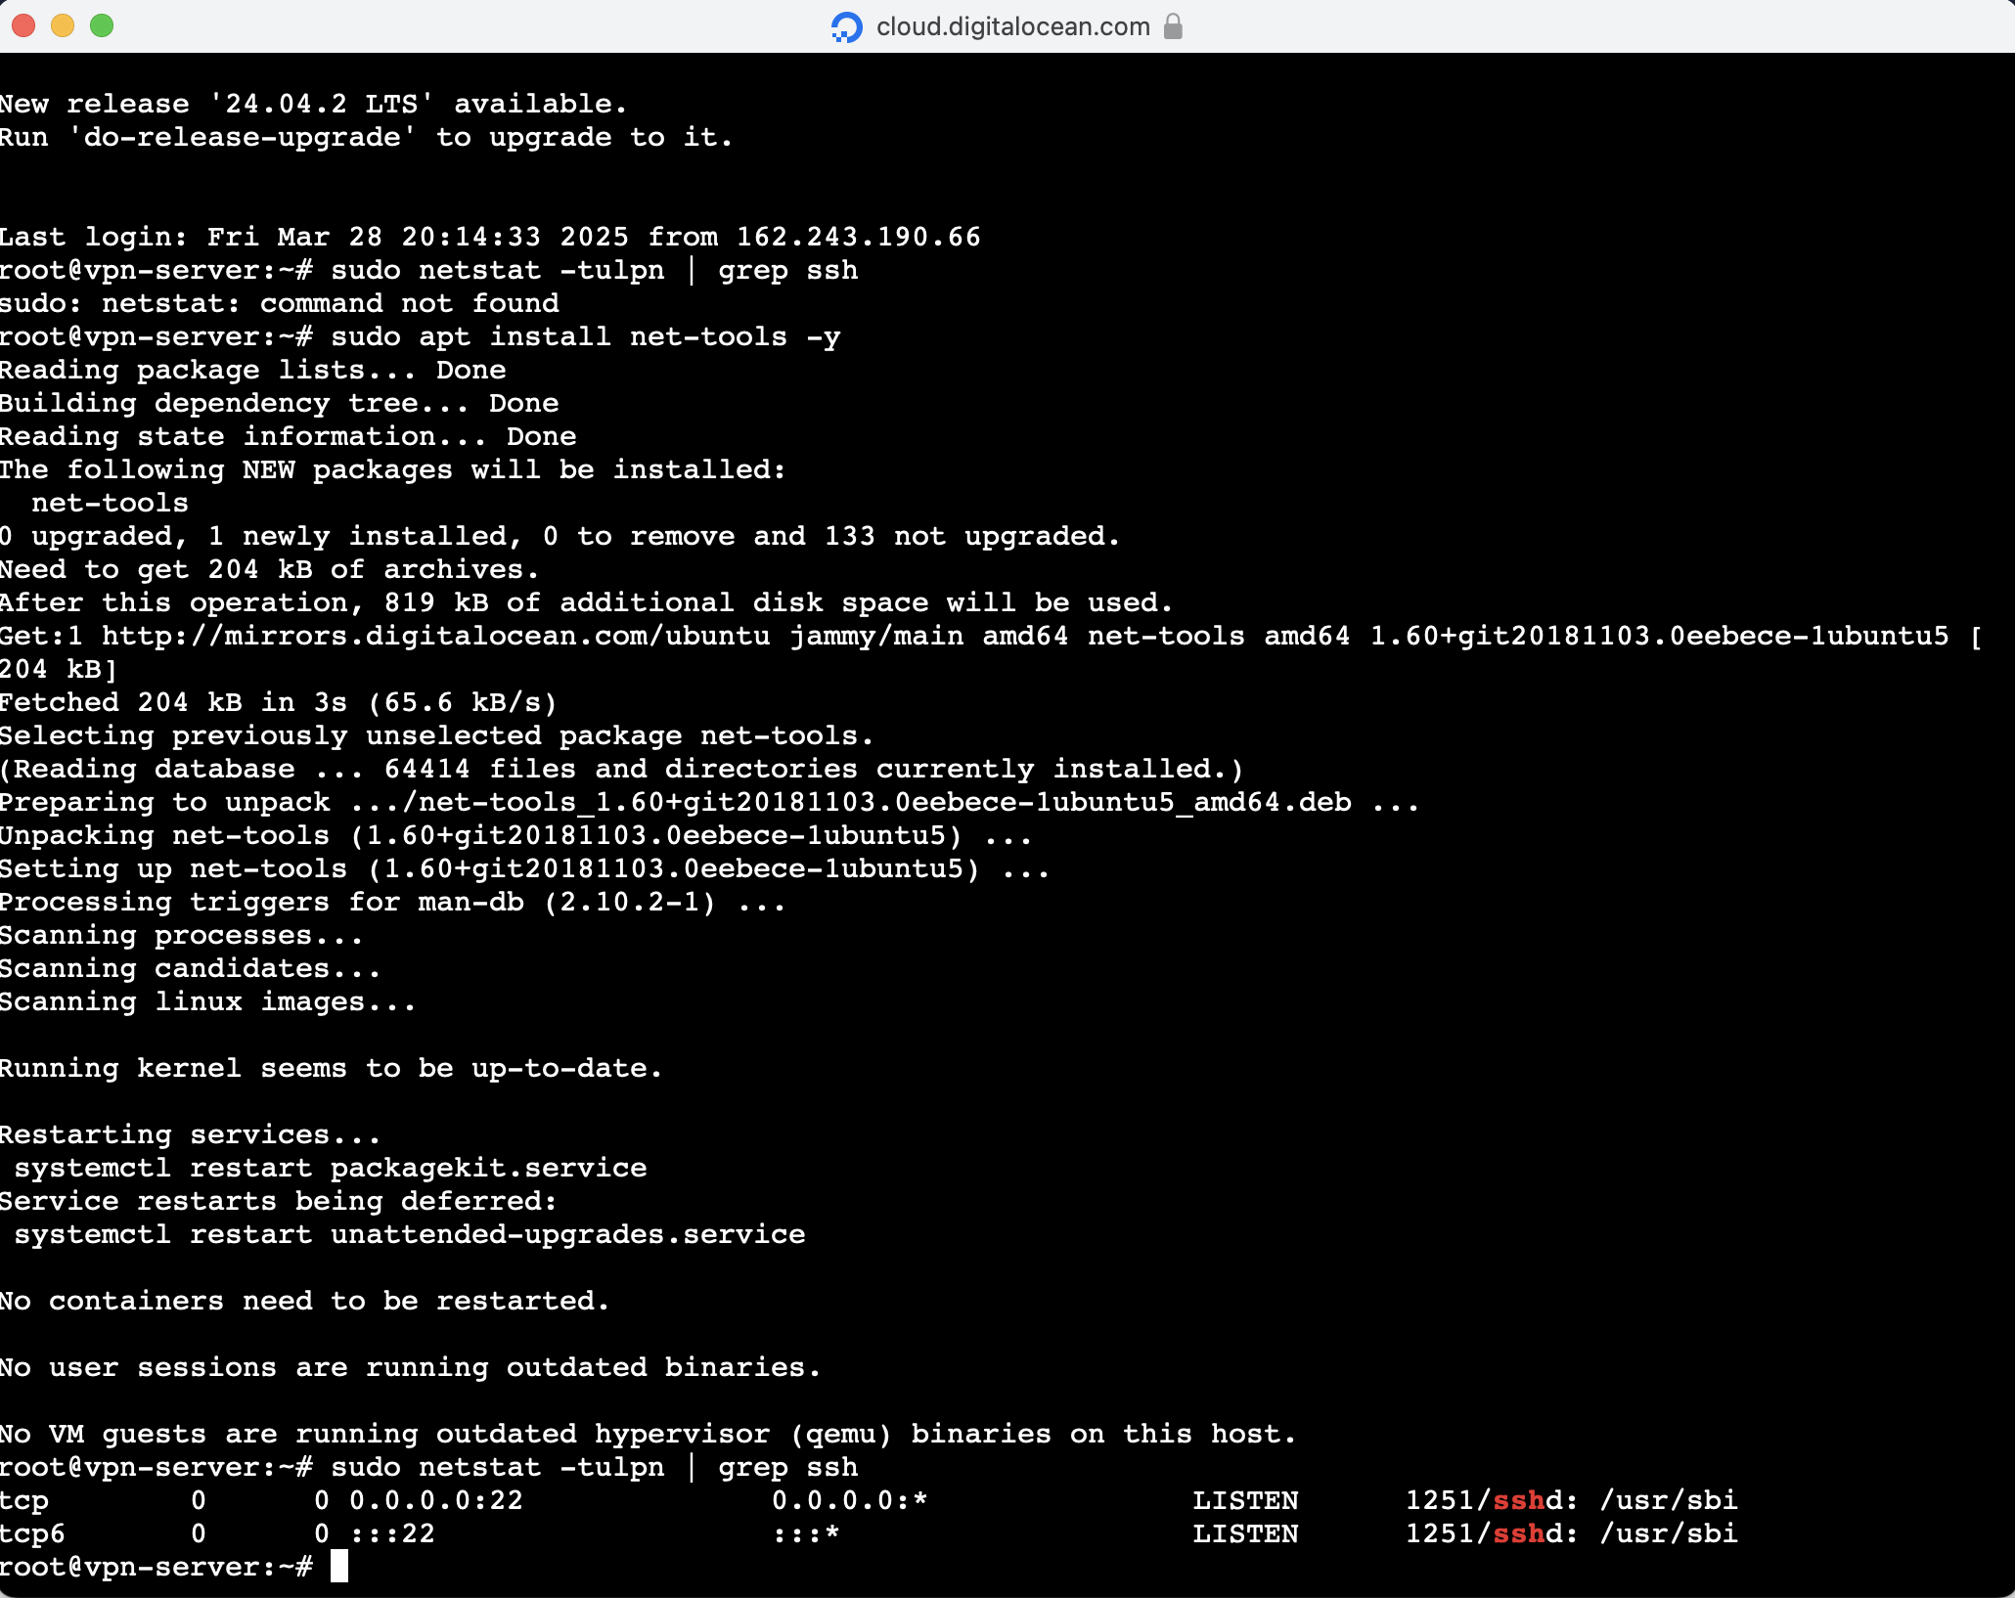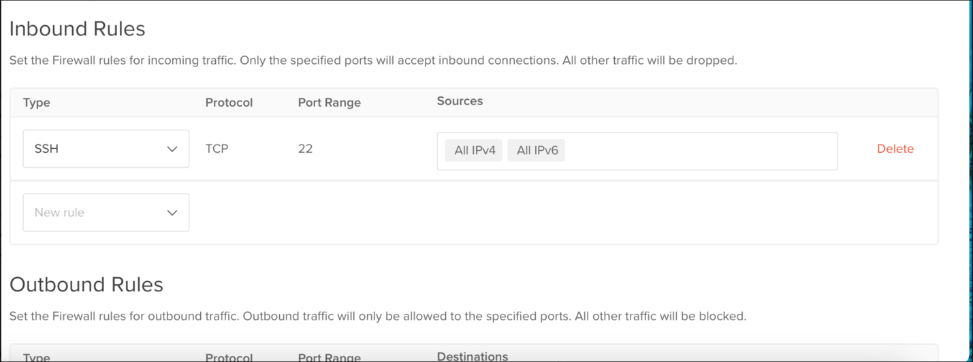In console, sudo apt update.

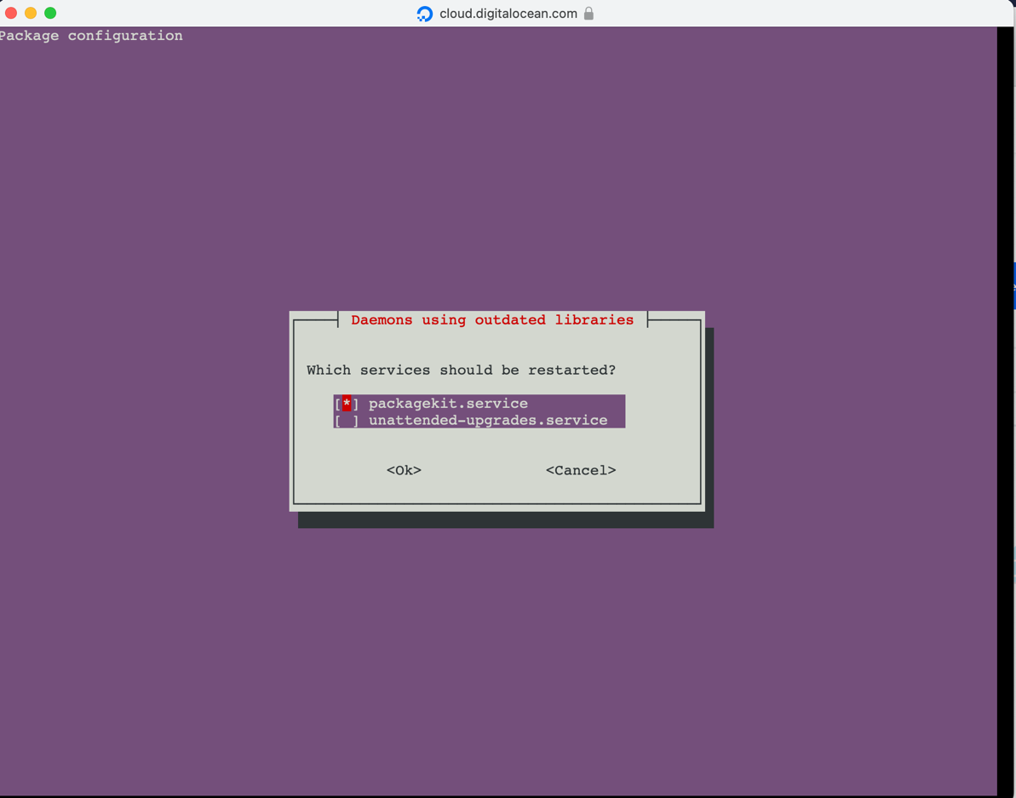

Clicked Tab and hit enter on <Ok>

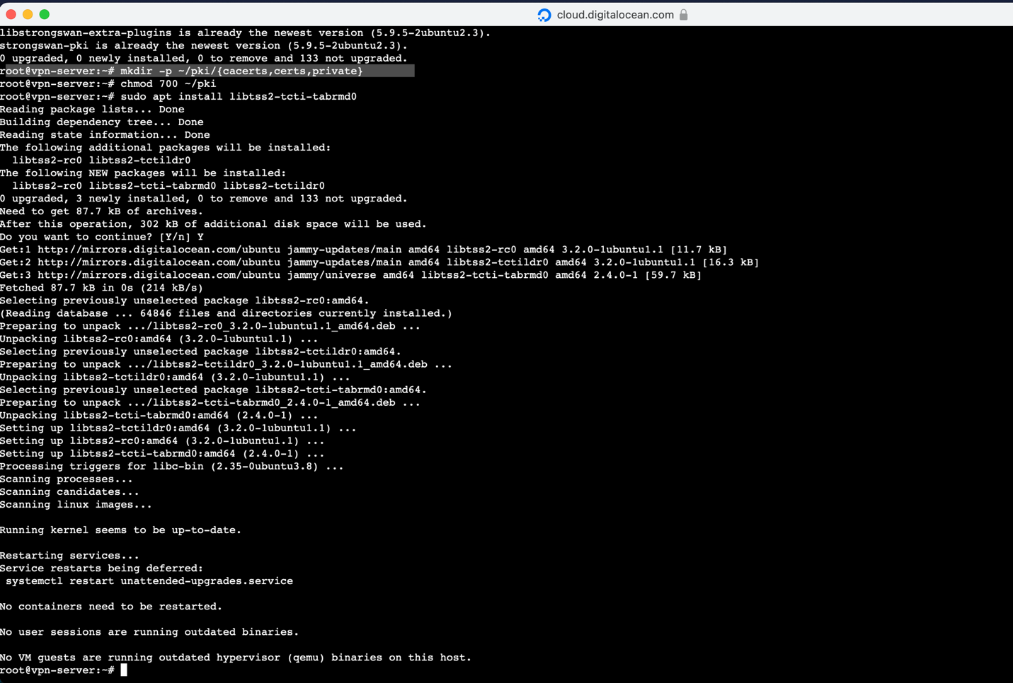Setting up a Certificate Authority on console: “mkdir… chmod 700 ~/pki

sudo apt install libtss2-tcti-tabrmd0”

**Creating the VPN Server Certificate and Key**

After writing down the IPv4 address of the droplet (143.198.238.89 in my case), I proceeded to generate the server key and certificate that would authenticate the VPN server. These commands were entered into the droplet console, continuing from the Certificate Authority setup.

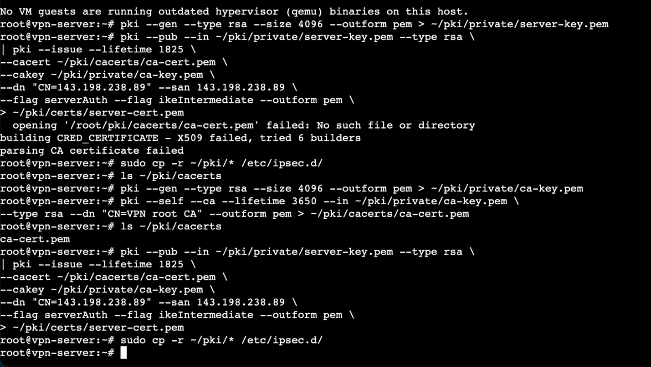First, I generated the server’s private key with the following command, and then, I created the public certificate for the VPN server using this command. I replaced the IP address with the actual public IPv4 address of my droplet. After the generation failed the first time, I retried the commands again until I was able to successfully achieve the output after running “**sudo cp -r ~/pki/* /etc/ipsec.d/”**

**Configuring StrongSwan: ipsec.conf**

To configure the VPN parameters, I first created a backup of the default StrongSwan configuration file and then opened a fresh file to define my own settings. Inside the vi editor, I pressed i to enter insert mode and typed in the VPN configuration shown below. This configuration sets up an IKEv2 VPN tunnel using the certificate generated earlier, and allows any client to connect using EAP-MSCHAPv2 authentication.

After typing the configuration, I pressed ESC, then typed :wq to save and exit the file.

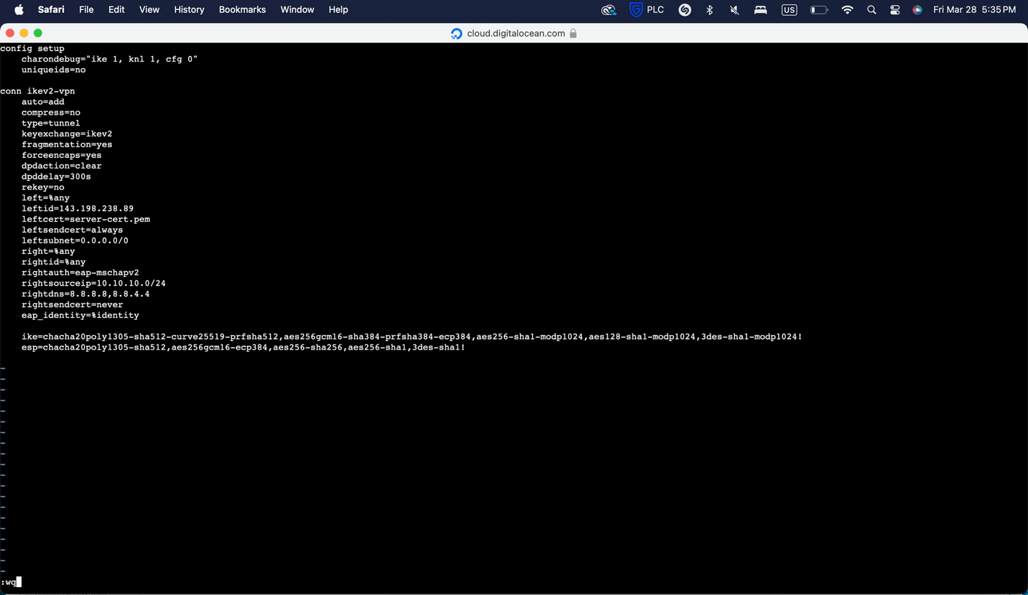This configuration allows IKEv2 clients to connect securely using certificates and usernames/passwords, and routes all client traffic through the VPN tunnel.

**Setting Up VPN Authentication: ipsec.secrets**

To configure VPN authentication, I edited the ipsec.secrets file which holds the shared secrets and private keys for StrongSwan.

****I ran the following command to open the file in vi editor: (screenshot)  
  
This sets up the VPN to authenticate using the server's RSA private key and allows a client with the username “user1” and password “password” to connect via EAP-MSCHAPv2.

I then pressed ESC and typed “:wq” to save and close the file.

**Restarting StrongSwan**

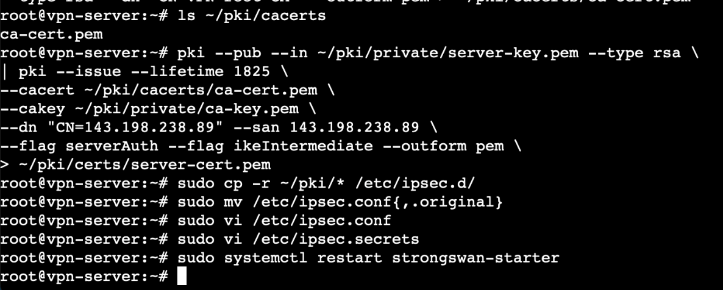To apply all changes made to the configuration files, I restarted the StrongSwan VPN service: **“sudo systemctl restart strongswan-starter”**. This command reloads the StrongSwan configurations and ensures the new VPN settings take effect.

**Configuring Firewall and Kernel IP Forwarding**

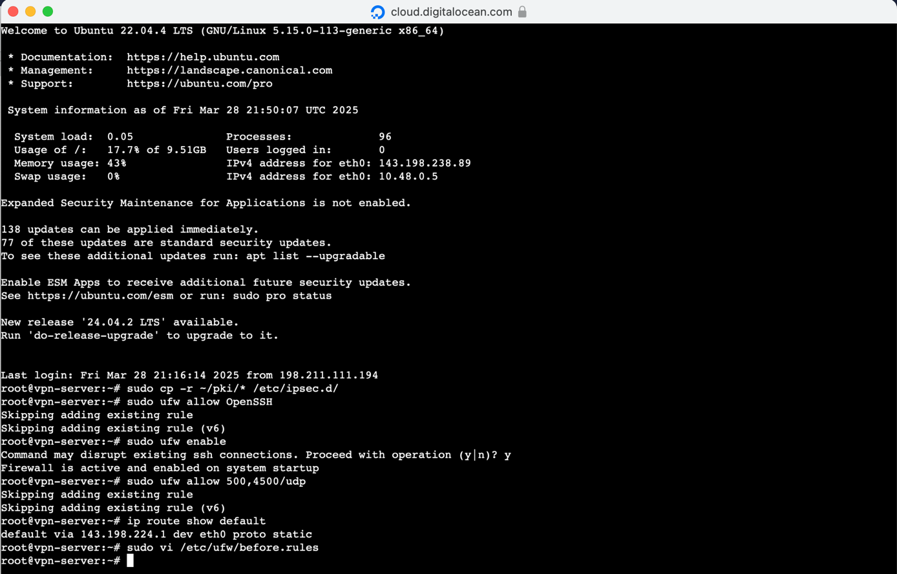Next, I configured the firewall to allow VPN-related traffic, including ports 500 and 4500 used by IPsec. I also checked the system’s default route and began editing the necessary UFW rules.

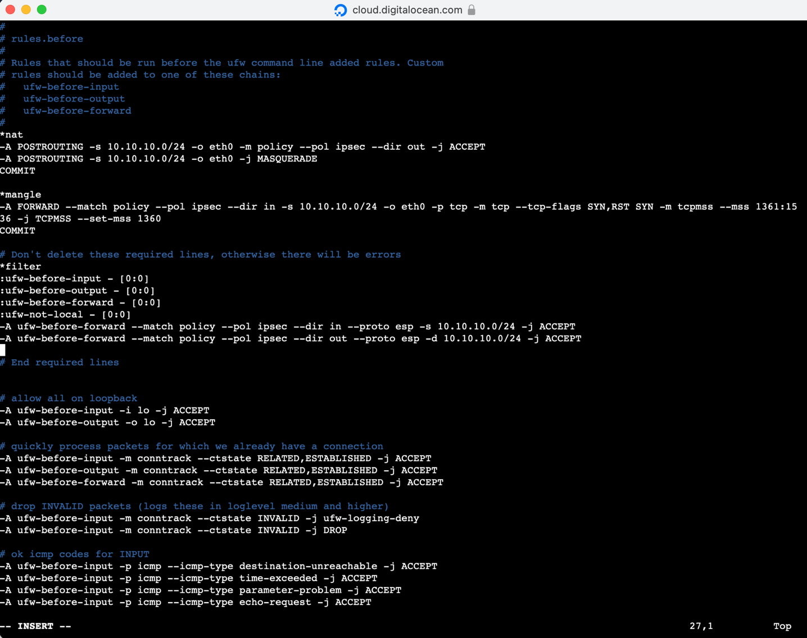

**Editing sysctl.conf for Kernel IP Forwarding**

To ensure that the server could properly route traffic between VPN clients and the internet, I configured the kernel’s networking behavior by editing the UFW system configuration file. Once inside the file, I pressed “i” to enter insert mode and added the following lines at the very bottom: “ net/ipv4/ip_forward=1

net/ipv4/conf/all/accept_redirects=0

net/ipv4/conf/all/send_redirects=0

net/ipv4/ip_no_pmtu_disc=1”  
These settings enable IPv4 forwarding and disable redirects, which are necessary for securing VPN routing behavior. After entering the text, I pressed ESC and then :wq to save and exit.

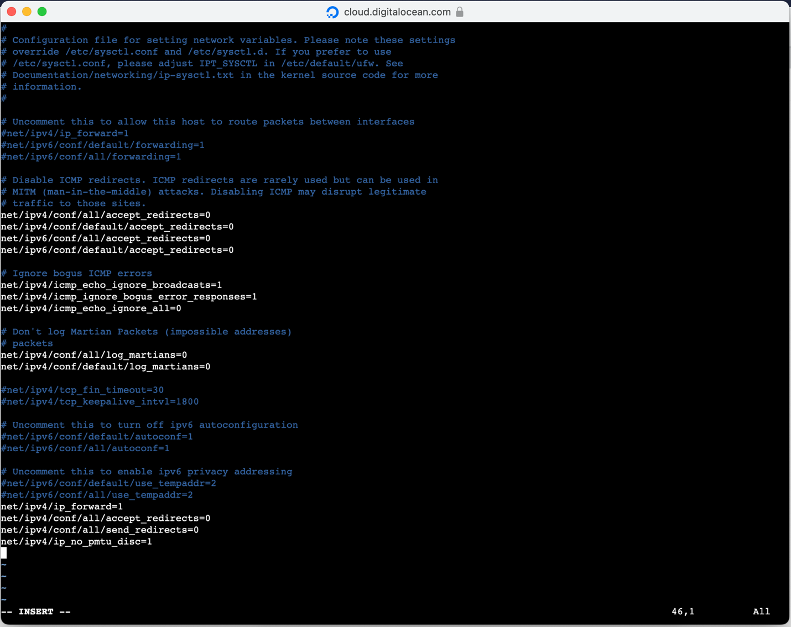**Restarting UFW to Apply Firewall Changes**

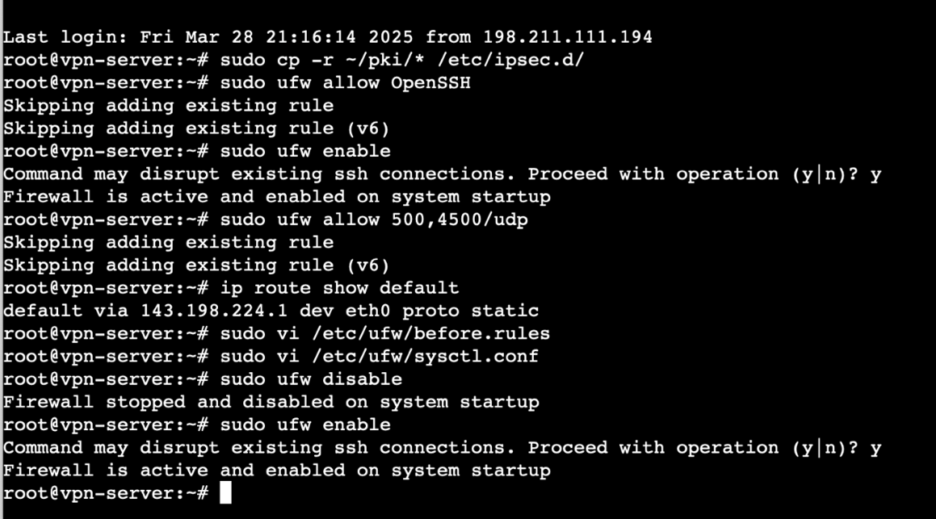Once the sysctl.conf changes were made, I restarted the firewall using the following commands: **“sudo ufw disable, sudo ufw enable”**

**Preparing for Windows VPN Client Configuration**

****I began preparing the client-side setup on a separate Windows machine, as required by the assignment. The first step was to obtain the server’s root Certificate Authority (CA) certificate to import it into the Windows certificate store.

Cert.pem certificate file saved on Notepad.

To do this, I ran the following command on the VPN server (DigitalOcean Droplet): cat /etc/ipsec.d/cacerts/ca-cert.pem

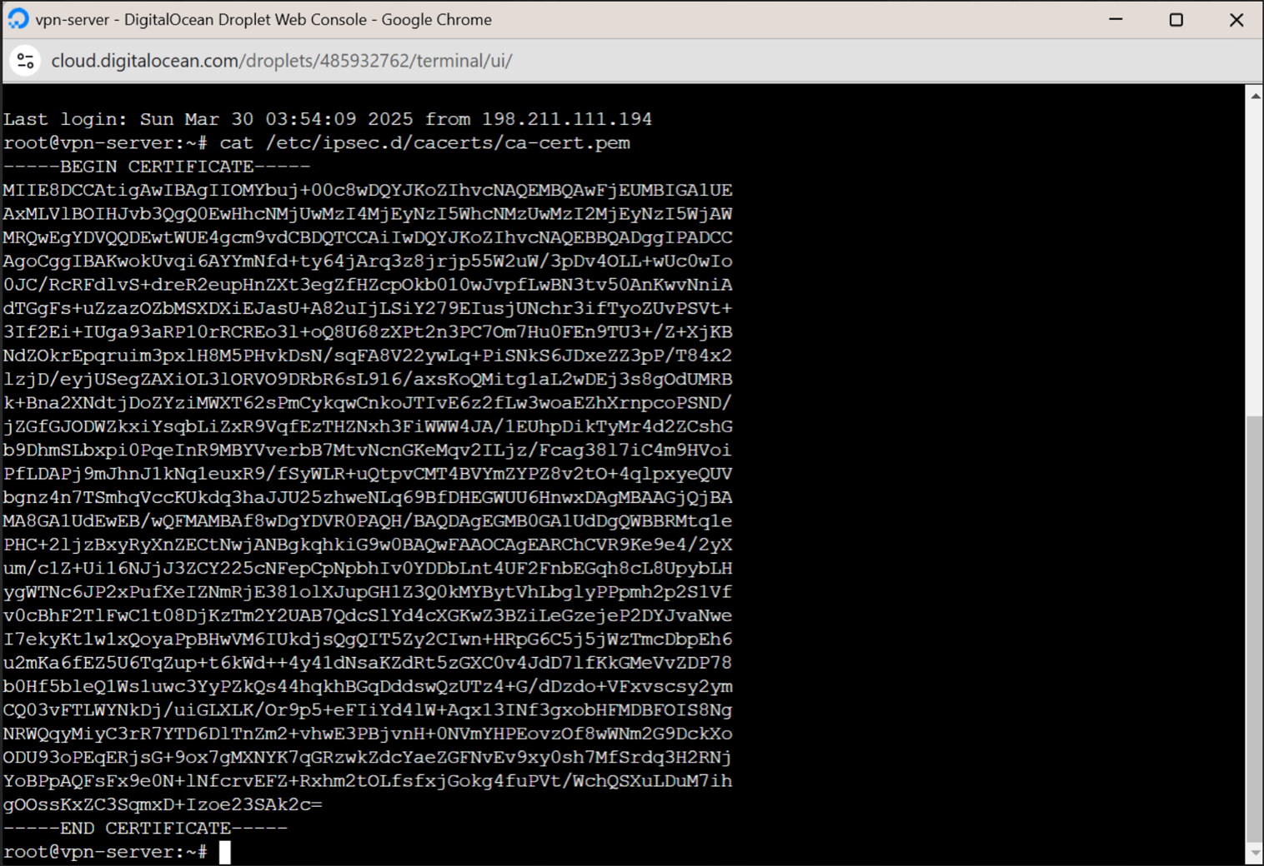

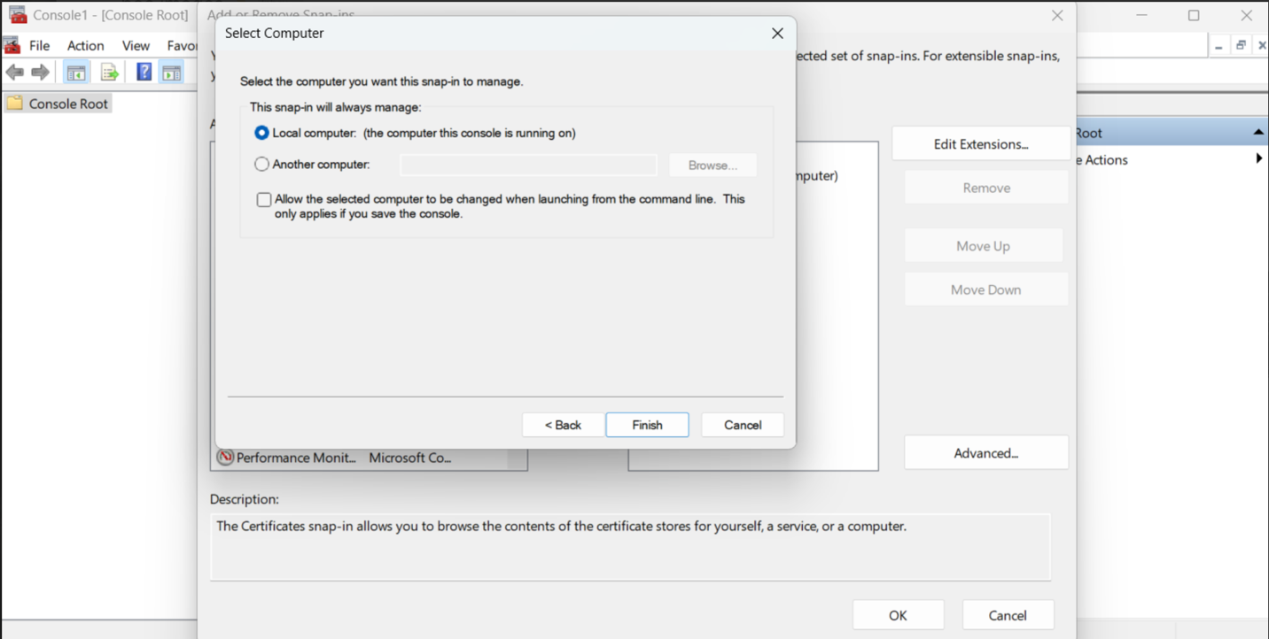  
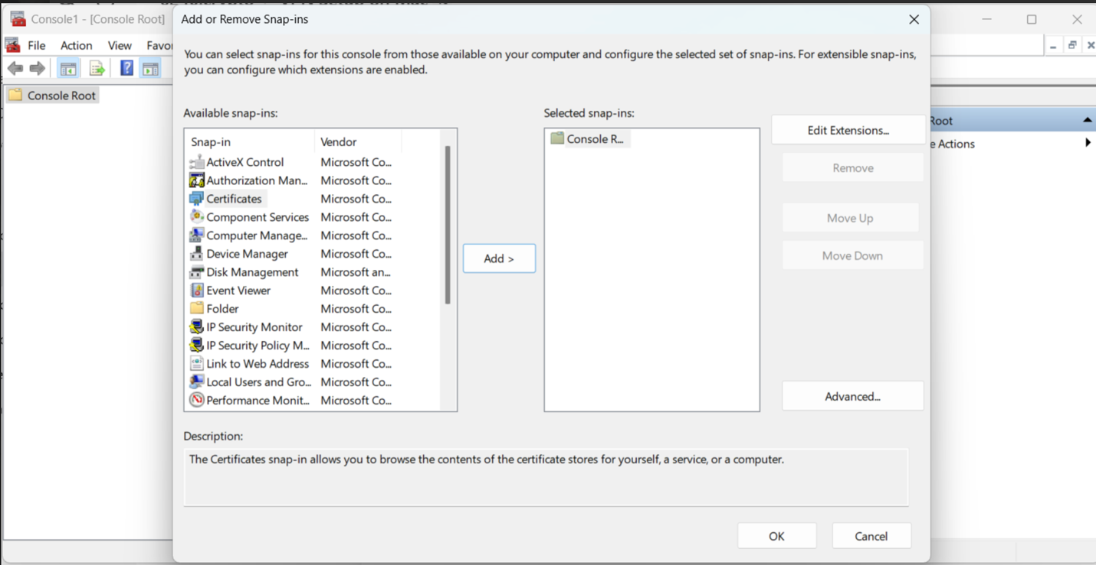Selected Local Computer

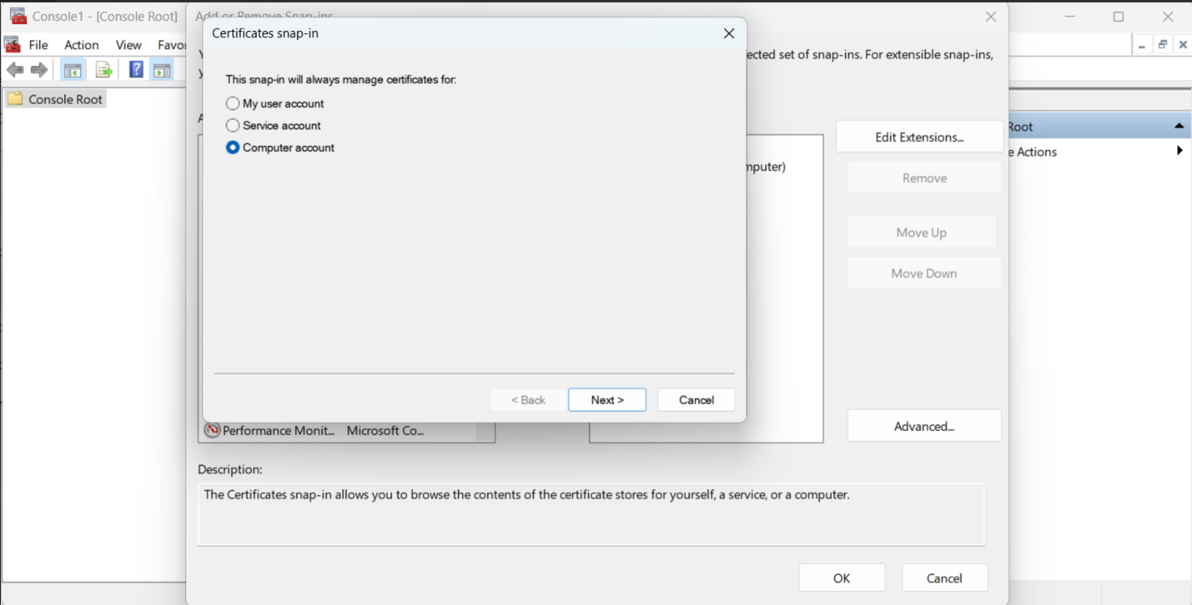And selected Computer account then clicked Next >

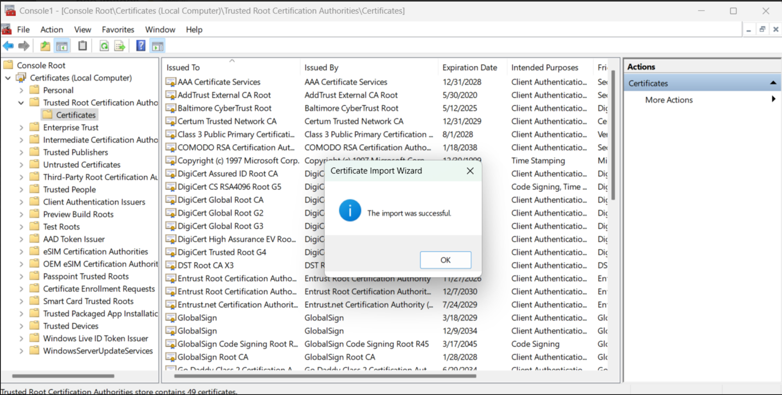  
All certificate files and the import of the cert.pem file shown successful.

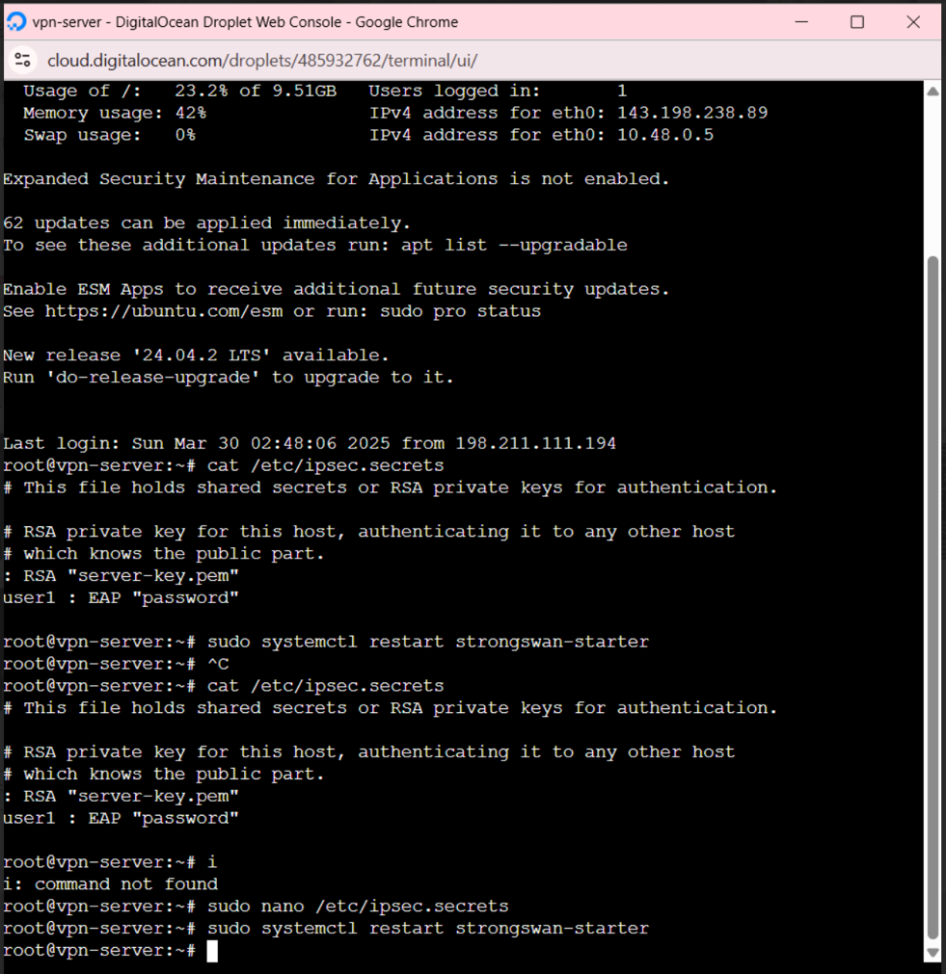**VPN Client Authentication Configuration**

To finalize the VPN authentication process, I edited the StrongSwan secrets file on the server, which defines how VPN clients are authenticated. I used the following command to open the secrets file: **sudo vi /etc/ipsec.secrets**. Inside the file, I modified the line to use a custom username and password for client authentication. Instead of the default user1, I created a personalized entry:  
*: RSA "server-key.pem"*

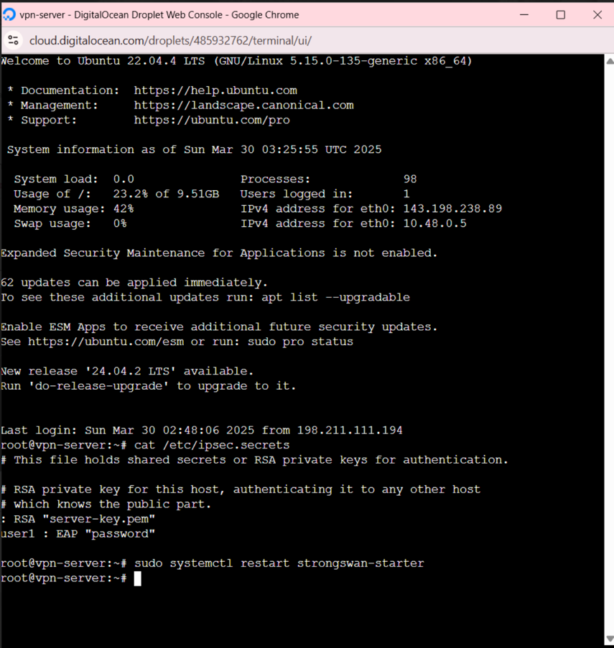*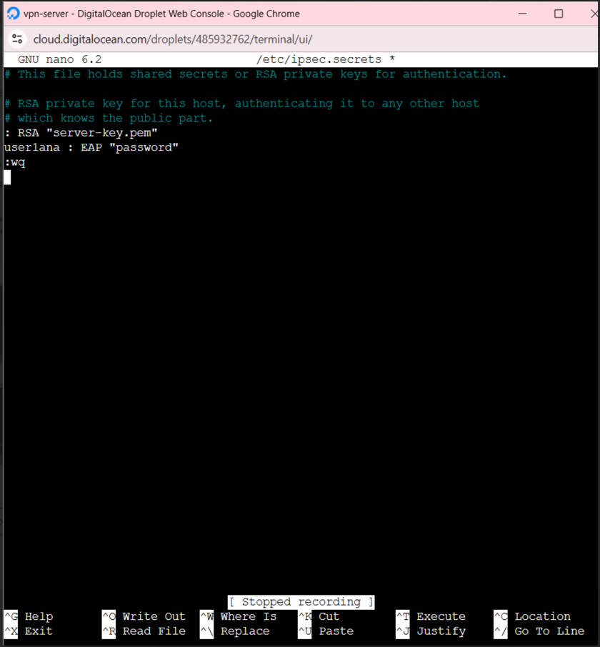user1ana : EAP "password"  
  
  
  
  
  
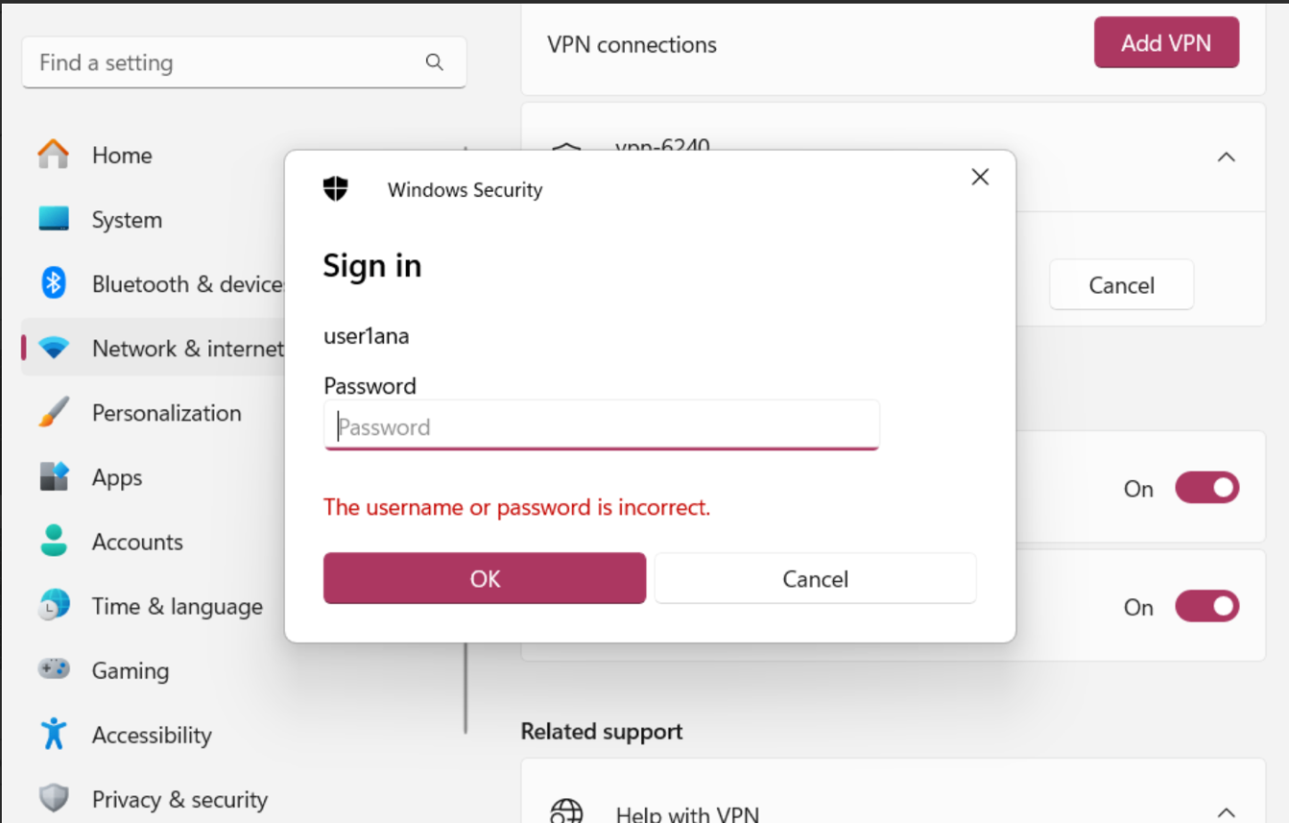*

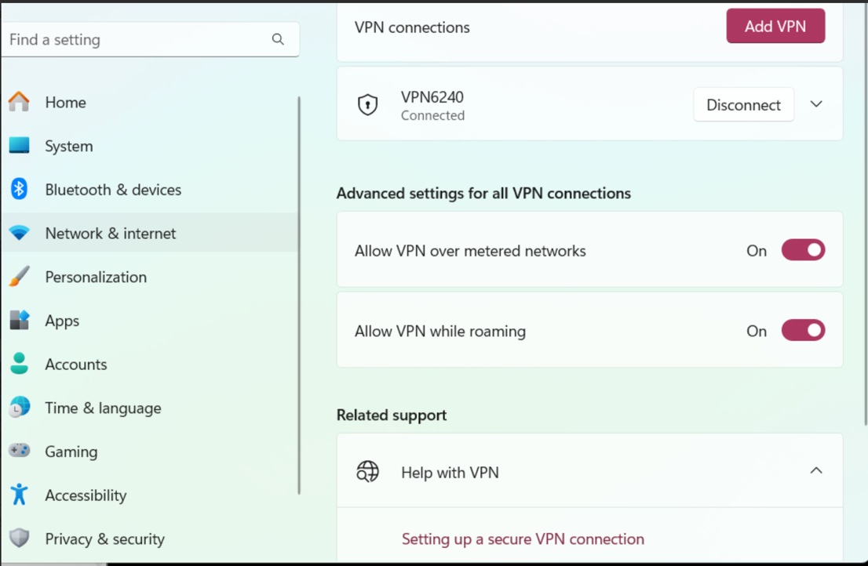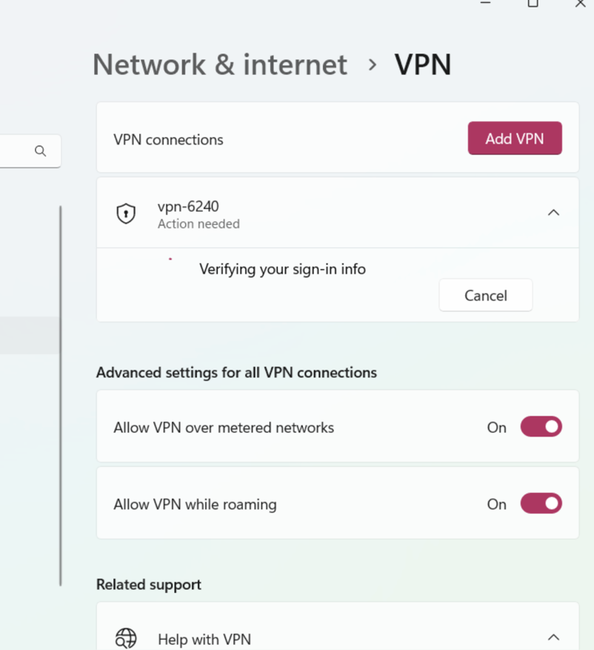  
VPN successfully added to network & internet settings under the name: VPN6240. Status shows connected.

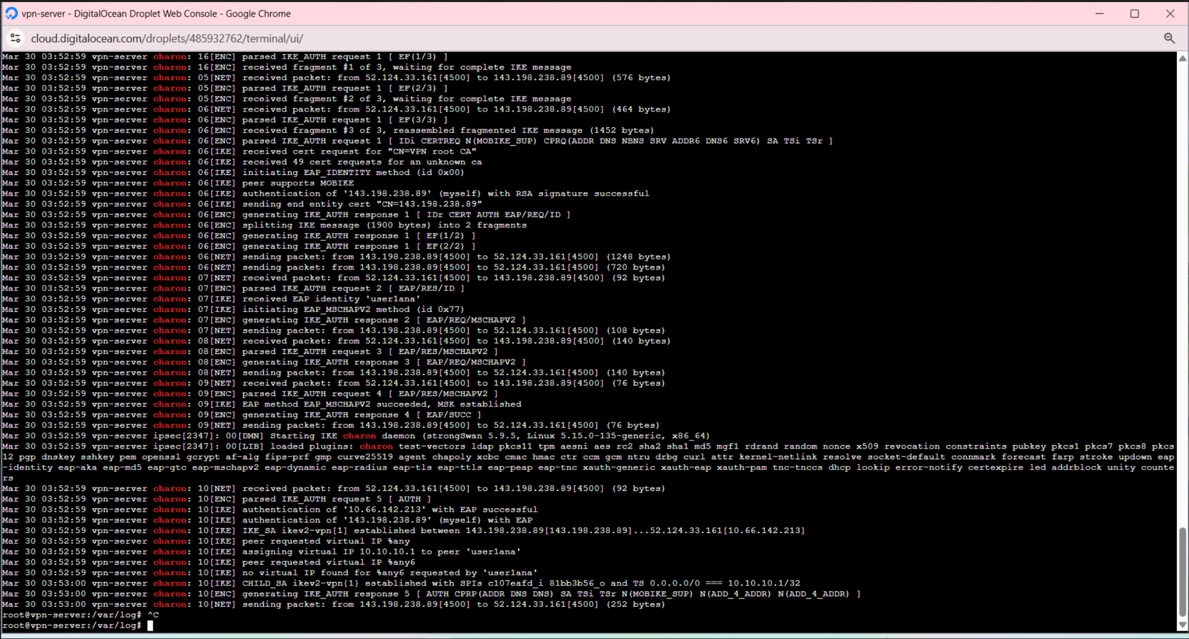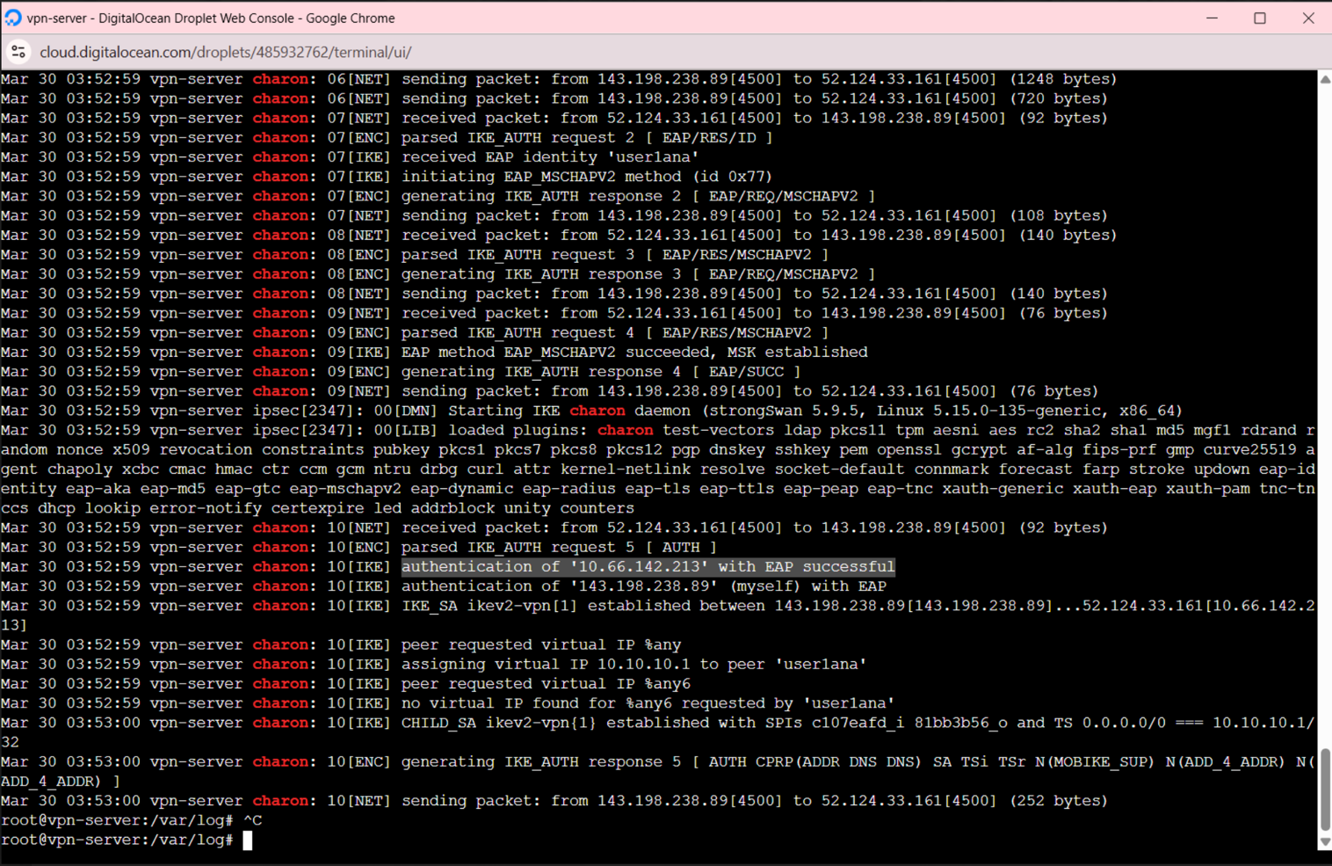Proof of established connection and successful authentication.